 | 
TTQ Coaching Success: Unit 4 Handout

1. Open a browser and click or type in the following url: http://groups.yahoo.com/groups/coachttq

2. You want to “Join This Group!” Click the “Join This Group” button.
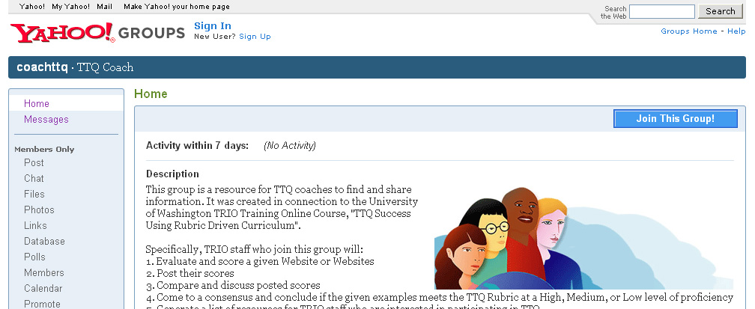

3. First, you need a Yahoo! ID. If you have a Yahoo! ID already, just login and wait for an approval. You’ll receive an email from the “coachttq” moderator letting you know you are a member.
If you don’t have a Yahoo ID, click the “Sign Up” link indicated by the red arrow below.

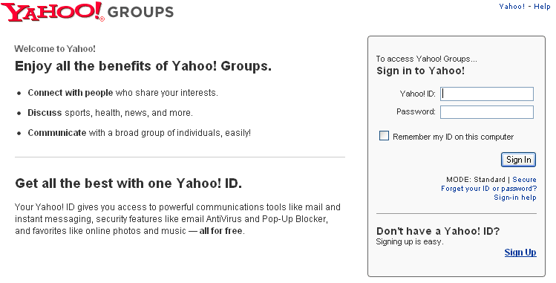

4. You now see a “Create Your Yahoo! ID” form. Be sure to fill out all areas with asterisks. Click the “I Agree” button in order to continue.

5. You should see a web page similar to the one below. This web page is important. Note the instructions below the image. 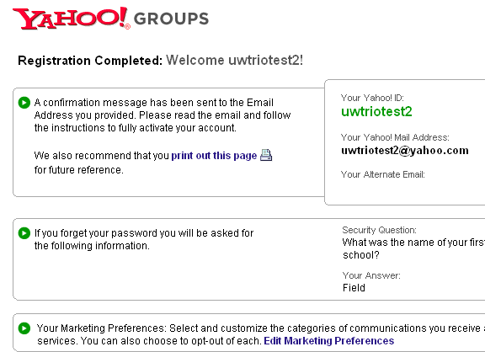
Example Answers
It is highly suggested that you print out this page (first red arrow above) and file it so that you have your ID, email address, Security Question, and Answer for later use.
IMPORTANT NOTE: The bottom of this page provides you a way to choose what marketing preferences you want with this account. If you don’t want travel or shopping emails sent to you, NOW is the time to opt-out! Click “Edit Marketing Preferences” to opt out of any marketing options. (The red arrow points to the link.) Make your changes, click Save, then go back to “Registration Completed” page.
Once back at the “Registration Completed” page, click “Continue to Yahoo! Groups”

6. You have registered for a Yahoo! ID but now you need to request membership to join the “ttqcoach” group. You will need to complete the form “Join This Group” at this time. There are several important features to pay attention to on this form. Please see the following instructions for Join This Group.

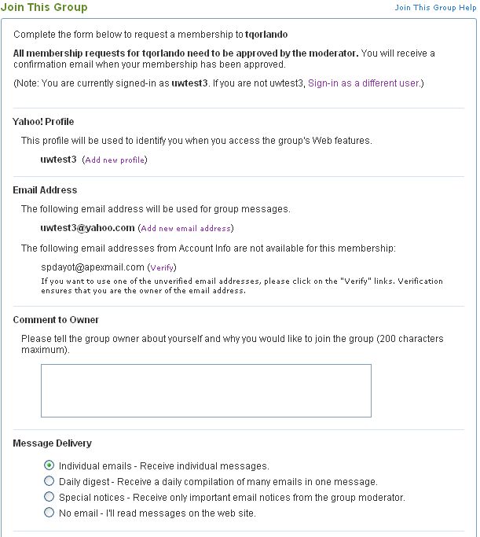
This means you can add information that you don’t mind sharing with the group. This is optional; you can skip it if you prefer.

If you want all your email messages to come to one particular email address, here is where you specify it. You will see “Add new email address” OR you can verify the email address you listed on your registration form. Either way you can change your messages from the Yahoo email to one you prefer.
Yahoo! requires that you make a comment to the owner of this group; a simple “Hello” will work.
Specify how often, or not, you want email messages from this group sent to you. Read through the choices and pick the one that suits your needs.
Hello. I look forward to joining this group.

:

Once you have completed this form, Click “Join”.

7. At this point in time, you must wait for the “coachttq” moderator to approve your membership. This is done on a daily basis, often several times a day. You will receive an email notification once you have been approved for the group.

8. Once you receive your confirmation, go to http://groups.yahoo.com/group/coachttq to collaborate with your colleagues!

